

Course Code : COMP6502

Course Name : Introduction to Programming

Class : L1BC -BLK

Name of Lecturer : Monica Hidajat

Major : CS

Final Project Report

Audio spectrum analyzer

Fauzan ATHALLAH Arief

2022

Audio Spectrum Analyzer

Name : Fauzan Athallah A.

ID : 2201798326

1. Description Concept:

A **spectrum analyzer** measures the magnitude of an input signal versus frequency within the full frequency range of the instrument. But this program was made to measure audio live by using microphone.

2. Design:

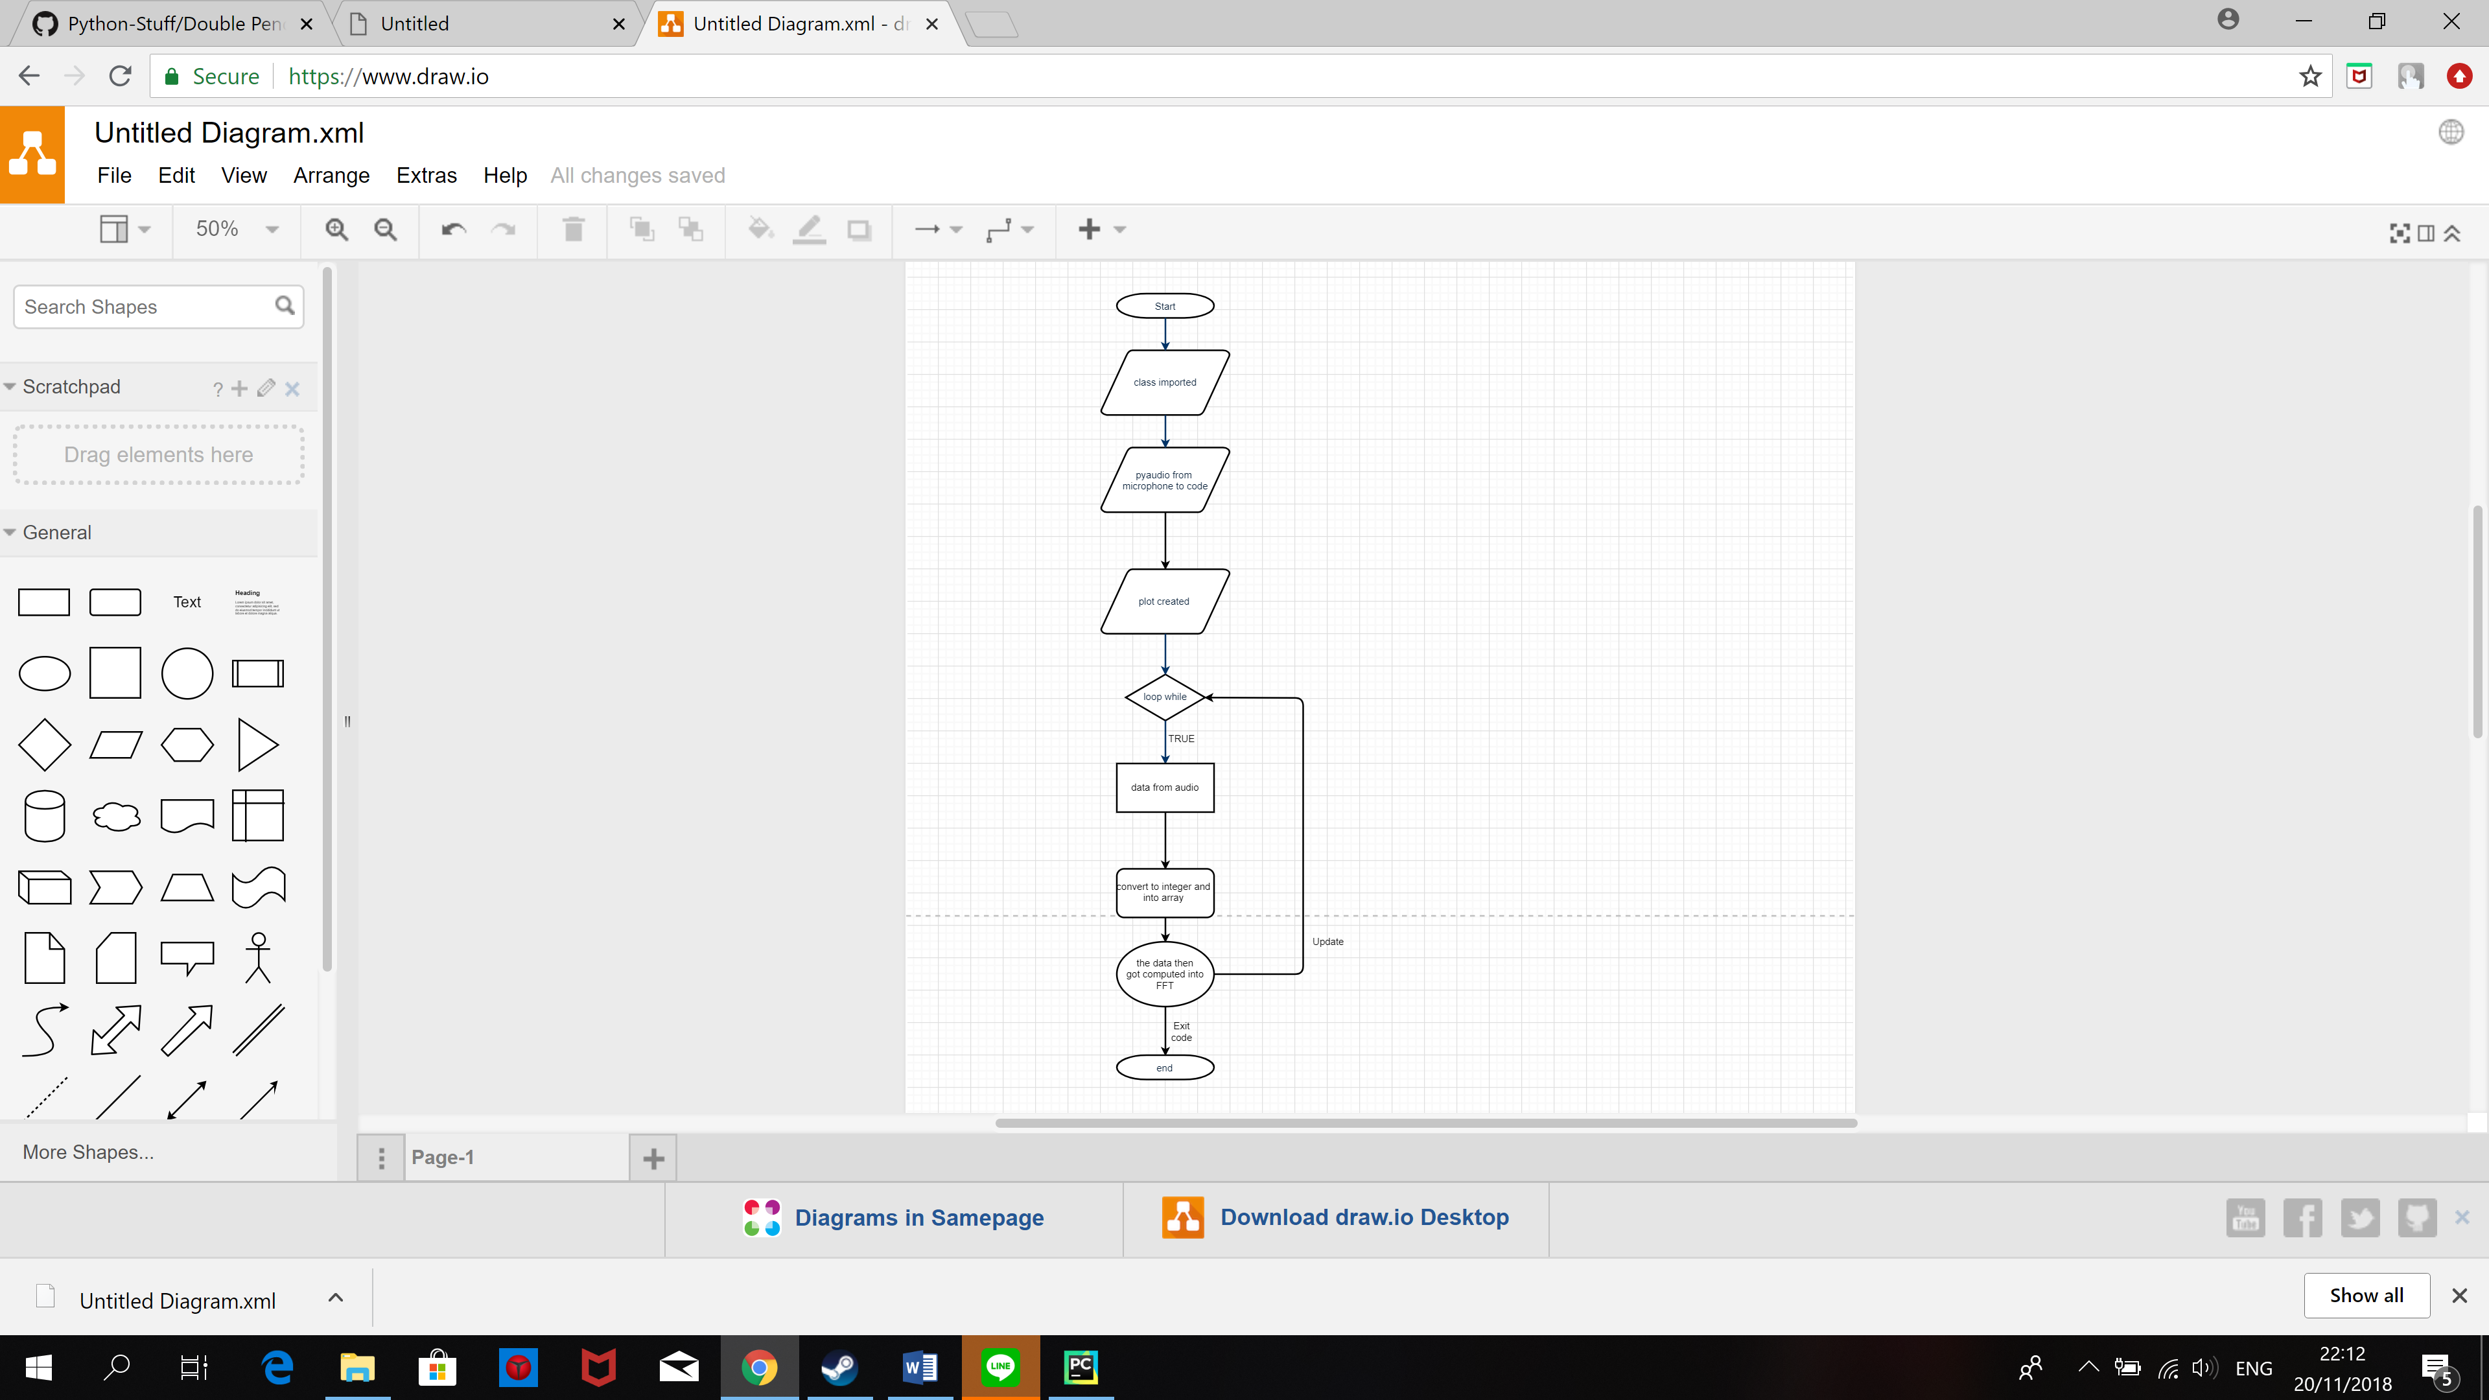

3. Discussion Implementation:

Python package that were implemented within the program include: MatPlotLib, NumPy, SciPy, and Pyaudio.

MatPlotLib was used as the main framework in the creation of this project as it served as the graphical representation of the audio frequency for the purpose of showing the audio waveform and the spectrum analyzer.

The NumPy was intended to be the math that supplement the plot framework that include array and list.

SciPy was included to calculated the data equation in the form of FFT. The FFT or Fast Fourier Transform spectrum analyzer uses digital signal processing techniques to analyzer a waveform with Fourier transforms to provide in depth analysis of signal waveform spectrum.

Pyaudio in this program was used as a connector from the microphone into the code itself. Which get then get displayed in the waveform plot and the audio spectrum.

How it works:

As the image shown in the design, the program start by creating the main two plot framework and then the sound that was recorded into a form of data from the microphone gets calculated in the FFT equation and the loop repeat again.

Class Explanation:

The pyaudio in this program can be described as a class because when it runs it don’t affect the variable and it always not the same because of the different sound that was inputted but it always runs properly based on the equation.

4. Evidence

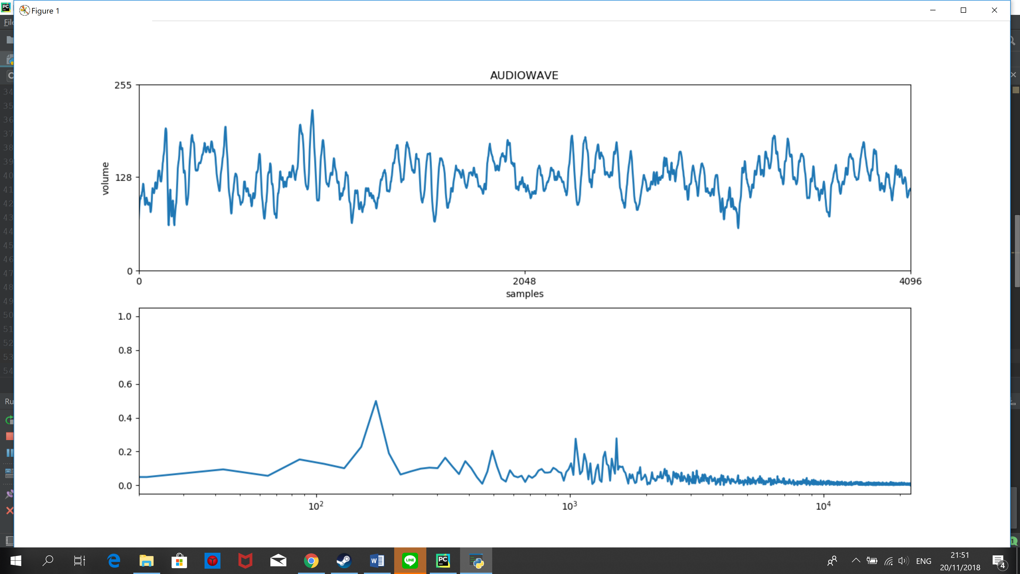

5. Resource:

<https://www.radio-electronics.com/info/t_and_m/spectrum_analyser/fft-analyzer.php>

<https://searchnetworking.techtarget.com/definition/spectrum-analyzer>